Database Project

Part1:Conceptual Model (ERD)

Contents

Problem Statement 3

Analysis 3

Results 9

# Problem Statement

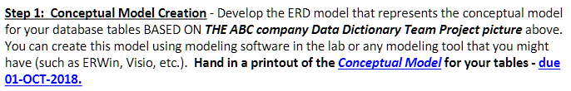

# Analysis

MetaCognition ERD Rev1 Update Explanation

* Removed Redundant attributes

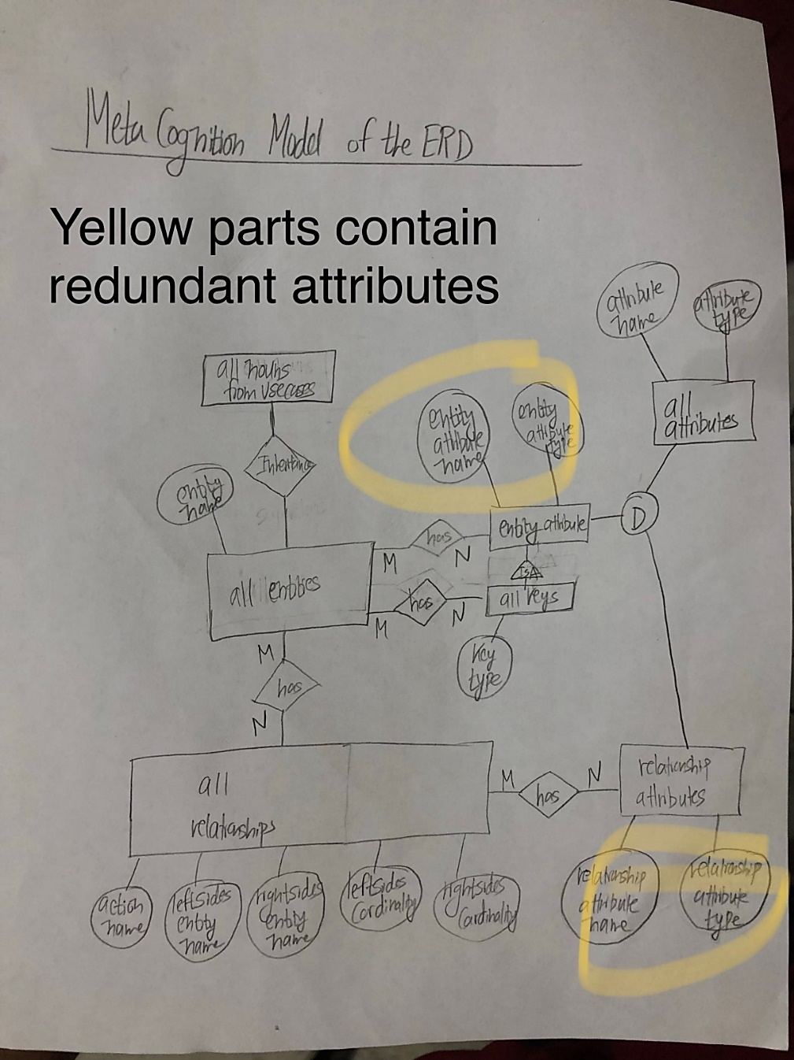

MetaCognition ERD Rev2 Update Explanation

* Refined Inheritance portion to reflect parent-child classes based on the book readings

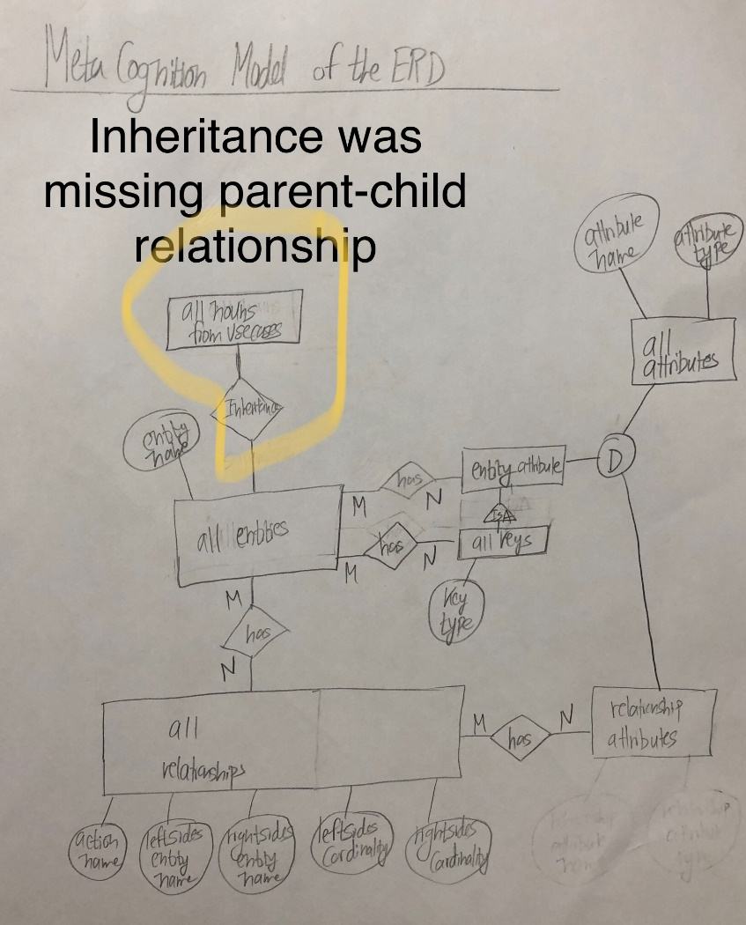

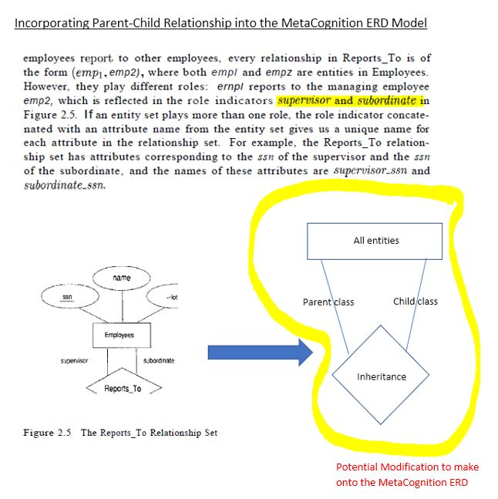

MetaCognition ERD Rev3

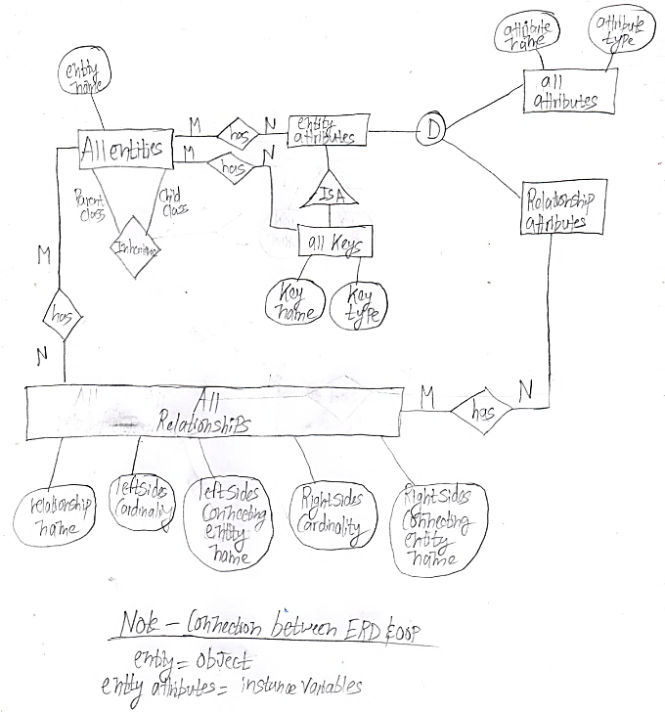

MetaCognition ERD Rev4

* Extracted all the variations out of the ABC Example and turned them into relationship statements

|  |  |
| --- | --- |
| **ACE Examples ERD** | **Relationship statements** |
|  | Entities & Attributes  One Entity has many entity attributes  One Attribute has many sub attributes  One Entity has one entity attribute that is a primary key  One Entity has one entity attribute of type derived value  One Entity has many entity attribute of type single value |
|  | Entities & Attributes  One Entity has many entity attributes  One Entity has One entity attribute that is a primary key  One Entity has One entity attribute of type single value |
|  | Entities & Attributes  One Entity has many entity attributes  One Entity has one entity attribute that is a primary key  One Entity has many entity attributes of type single value |
|  | Entities & Attributes  One Entity has many entity attributes of type single value |
| **ACE Examples ERD** | **Relationship statements** |
|  | Entities & Attributes  One Entity has many entity attributes  One Entity has one entity attribute that is a primary key  One Entity has many entity attribute of type single value |
|  | Entities & Attributes  One Entity has many entity attributes  One Entity has many primary keyes |
|  | Entities & Attributes  One Entity has many entity attributes  One Entity has one entity attribute that is a primary key  One Entity has many entity attributes of type single value |
|  | Entities & Attributes  One Entity has one entity attributes of type single value |
|  | Entities & Attributes  One Entity has one entity attributes of type single value |
| **ACE Examples ERD** | **Relationship statements** |
|  | Relationships  One Entity is another Entity **or** another Entity  One Entity **Works** in many Entities  One Entity **Manages** one Entity  Many Entities **owns** many Entities  One Entity **is within** many Entities  One Entity **offers** many Entities  One Entity **contains** many Entities  Many Entities **stock** many Entities  Many Entities **builds** many Entities  Many Entities **designs** many Entities  One Entity is **assigned to** many Entities  One Entity **hires** many Entities  One Entity **works on** many Entities  One Entity **schedules** many Entities |
|  | Relationships  One Relationship has One Descriptive attribute |

# Results

* Used the relationship statements to draw out the ERD Rev 4 Diagram

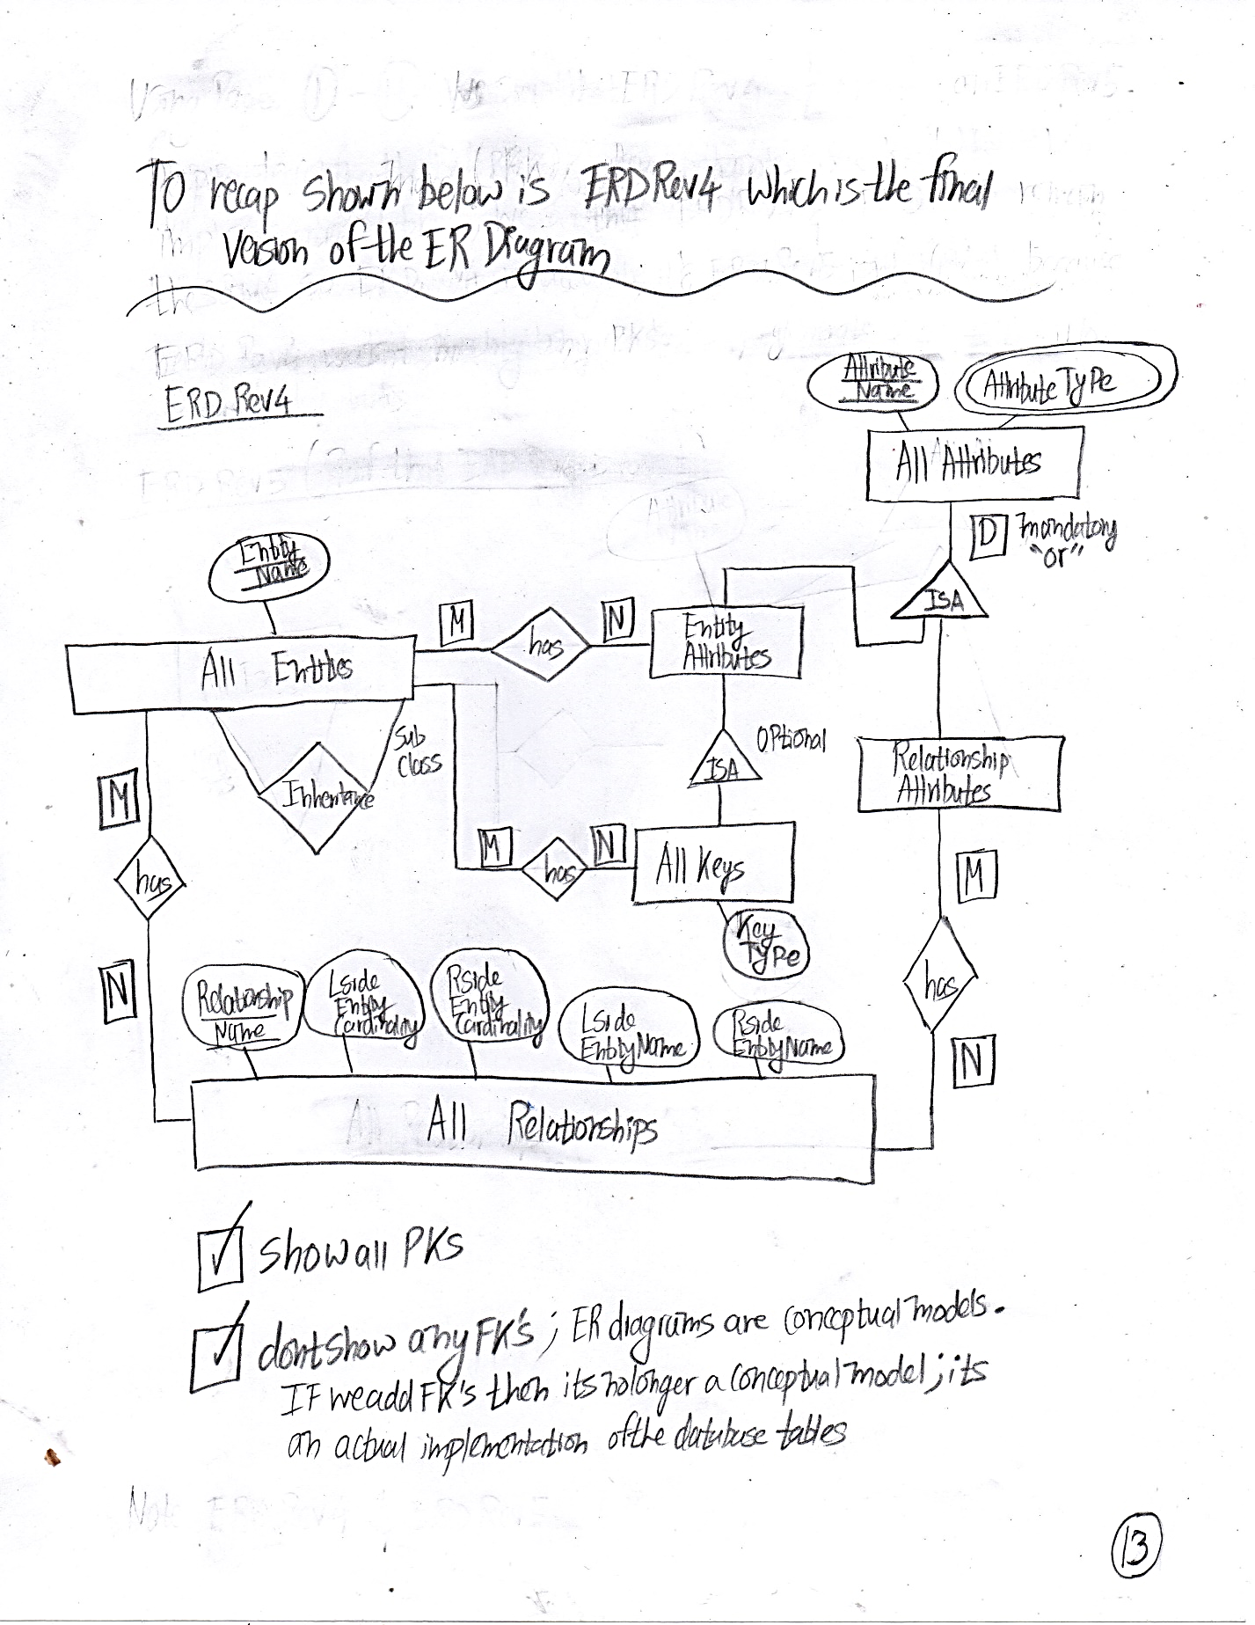

* Extracted all the variations out of the ERD Rev 4 Diagram and turned them into relationship statements

